**資料庫管理系統**

第二次練習

|  |  |  |
| --- | --- | --- |
| 班級:資一乙 | 學號:3a632093 | 姓名:黃名廷 |
| 缺少: | 錯誤: |  |

目錄

<ex>以northwind 為例，查詢員工的[員工編號],[姓名],[職稱],歲和年資 1

<ex>建立使用者自訂資料型別:address char(60) 2

<ex>以northwind 為例，再刪除參考主鍵或更新外來鍵時會導致違反參考原則，資料庫管理系統可能有三種處理方式 3

1.限制用法 6

2.連鎖法 7

3.空值化法 9

查詢 產品編號 53(鹽水鴨) 11

請寫出正規化的過程並寫出各個資料表的欄位名稱、型態與大小 12

1st NF 13

2nd NF 功能相依圖 14

關聯表 14

## <ex>以northwind 為例，查詢員工的[員工編號],[姓名],[職稱],歲和年資

select [員工編號],[姓名],[職稱],歲=year(getdate())-year([出生日期]) ,year(getdate())-year([雇用日期]) 年資 from [dbo].[員工]

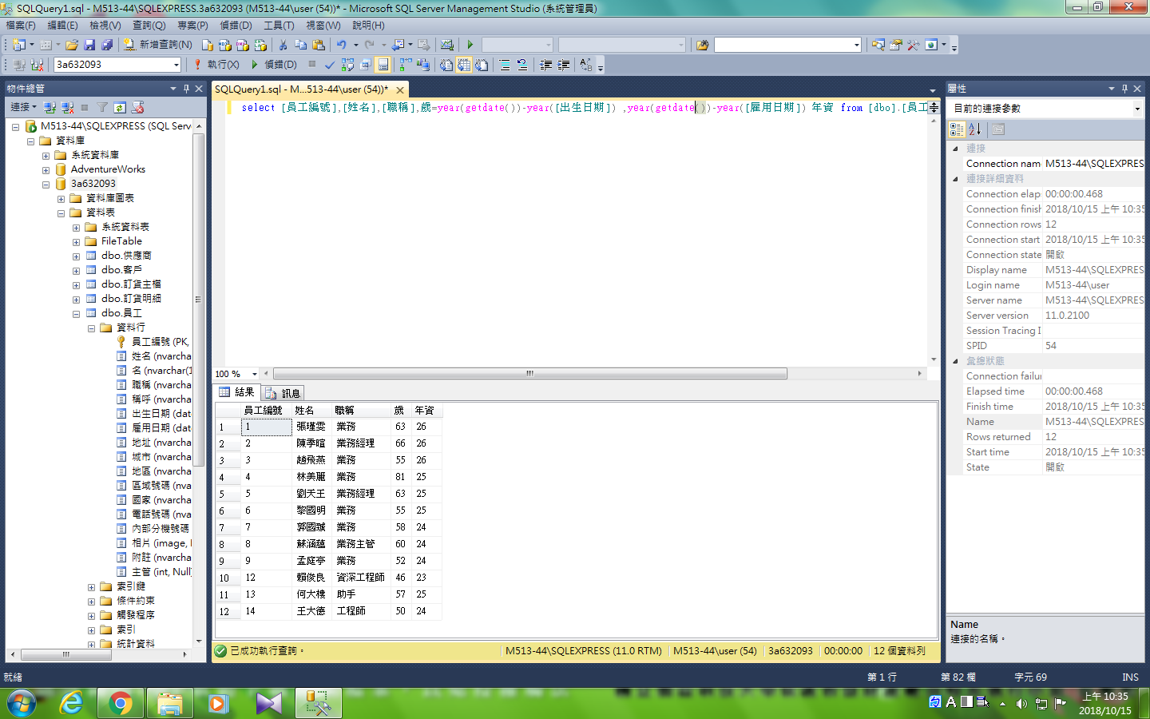

## <ex>建立使用者自訂資料型別:address char(60)

sp_addtype address, 'char(60)'

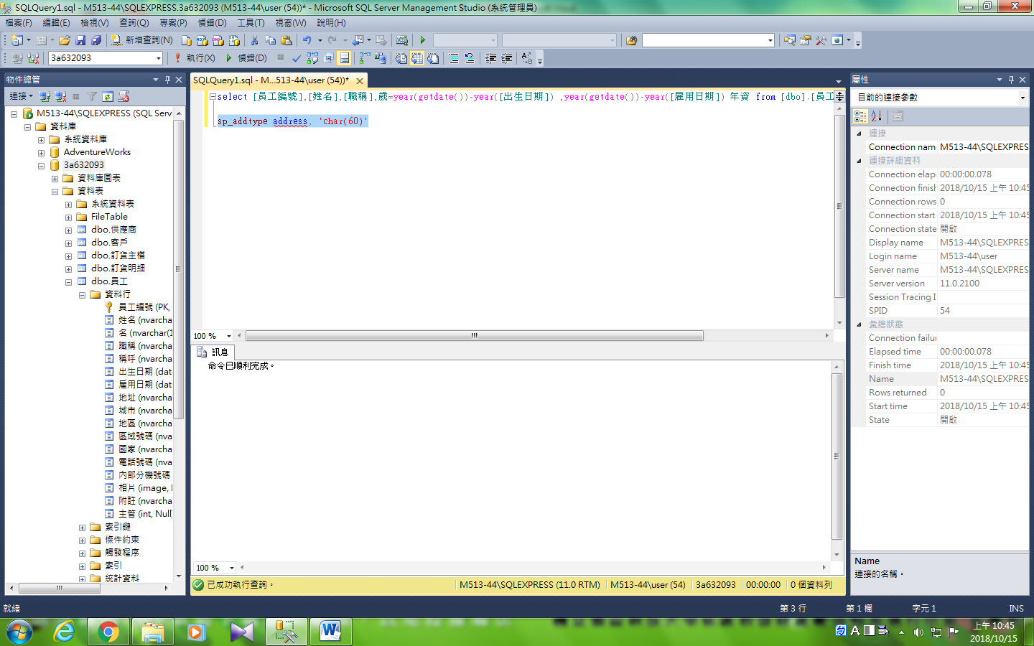

驗證

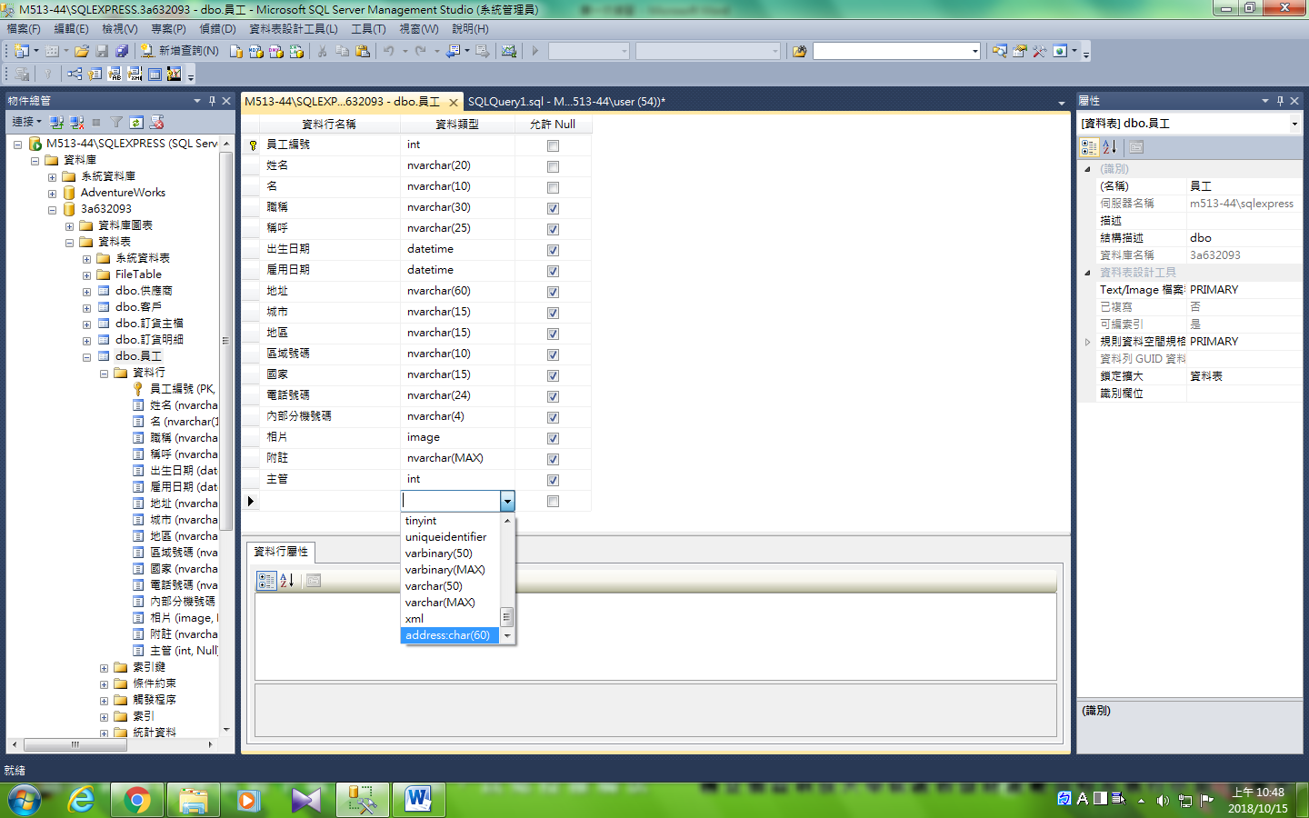

## <ex>以northwind 為例，再刪除參考主鍵或更新外來鍵時會導致違反參考原則，資料庫管理系統可能有三種處理方式

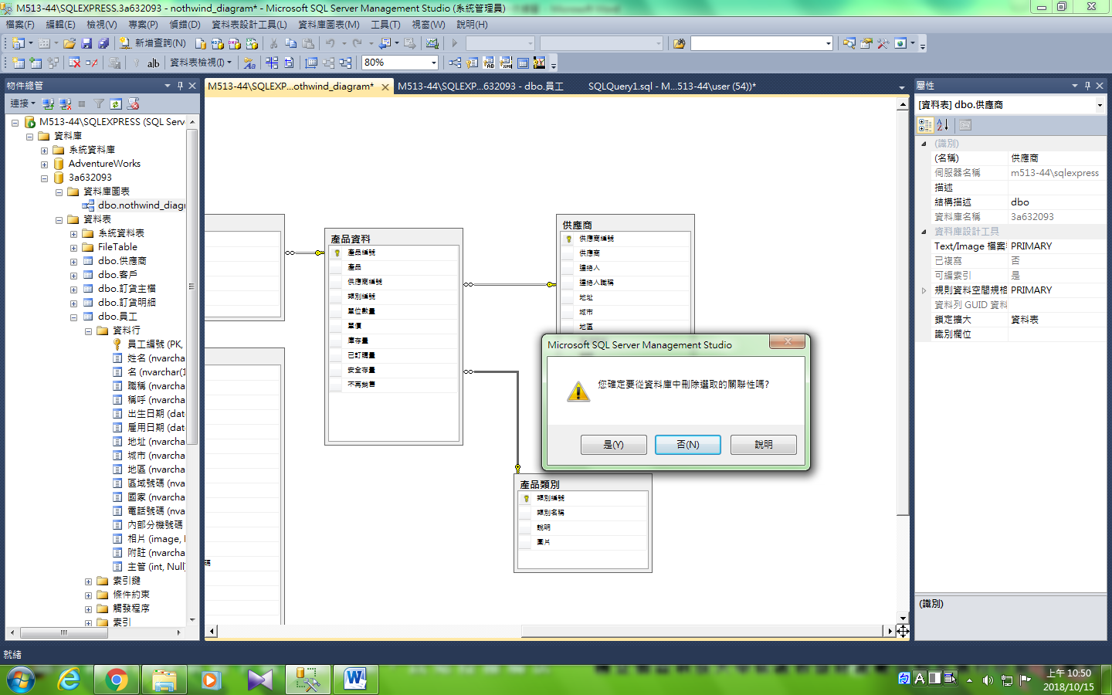

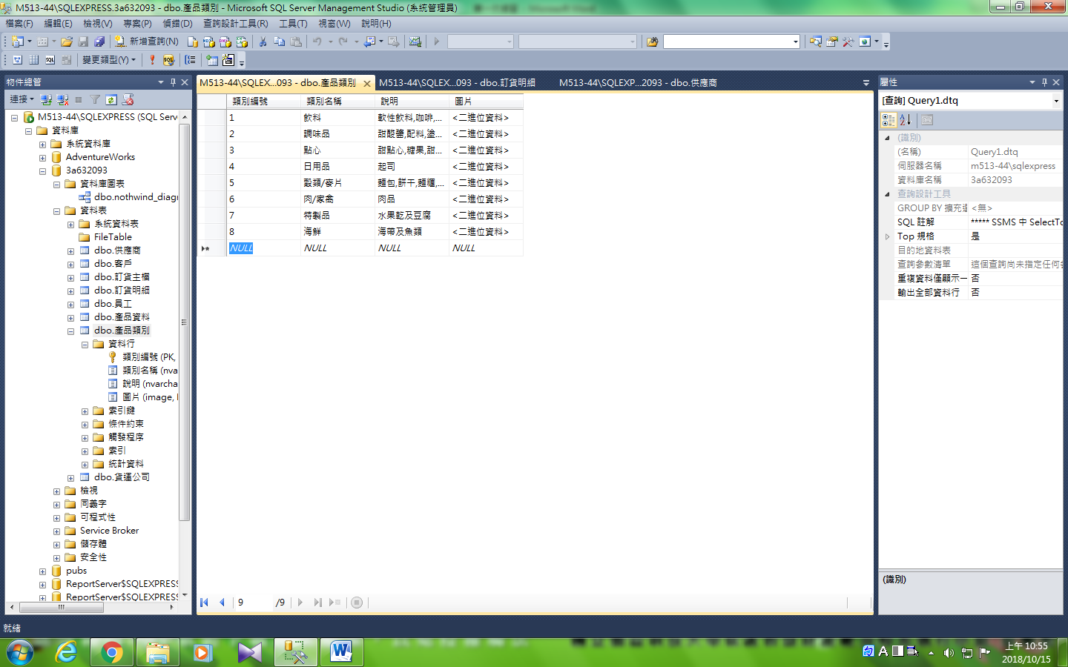

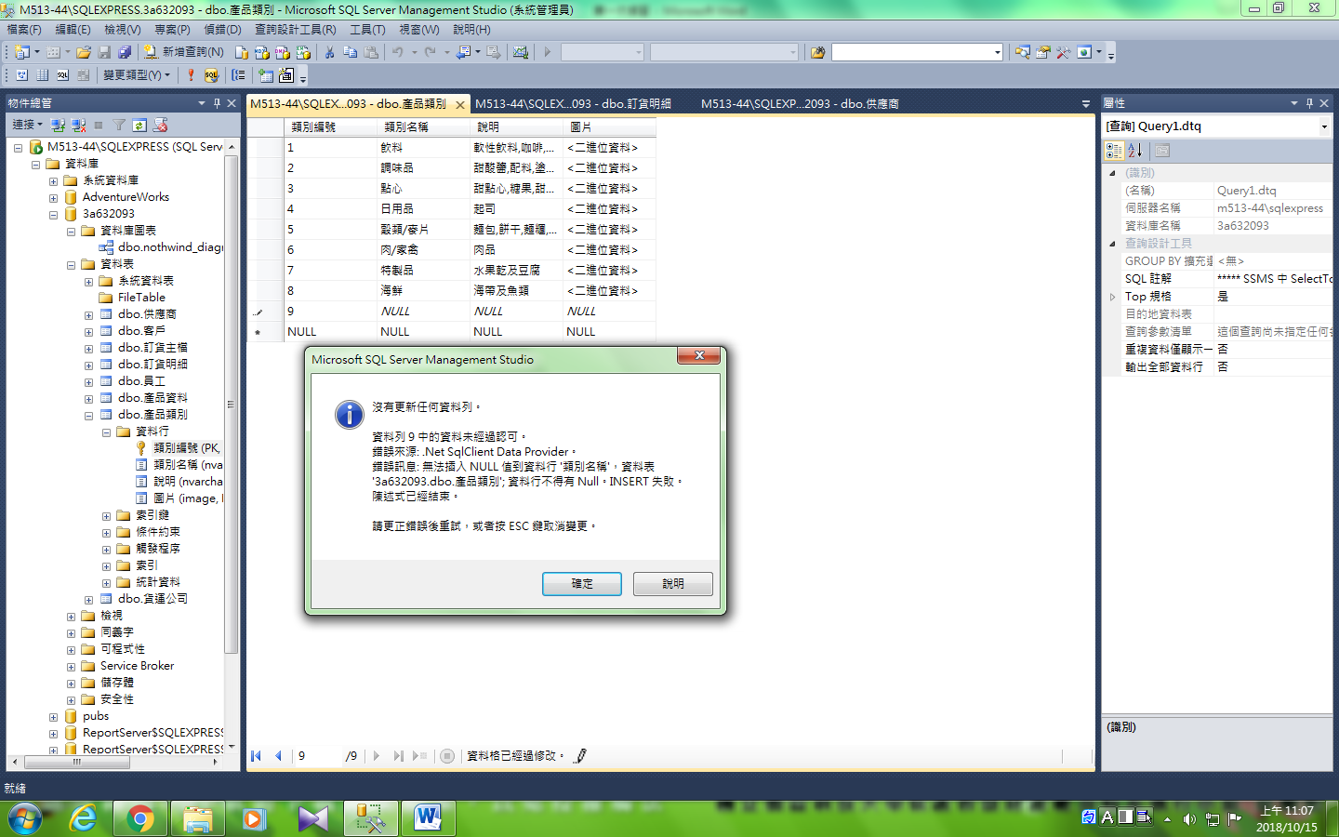

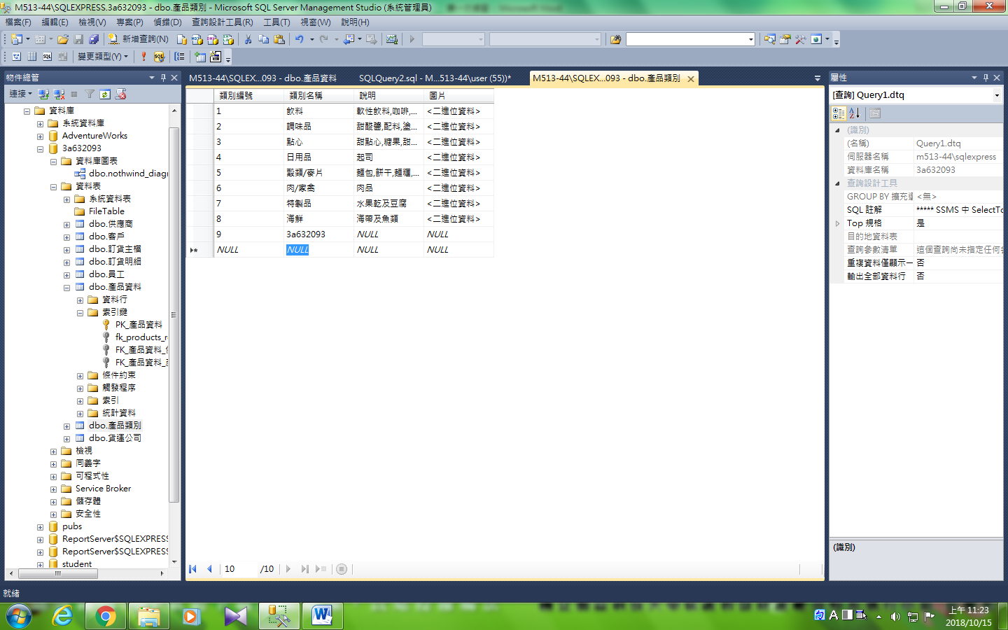

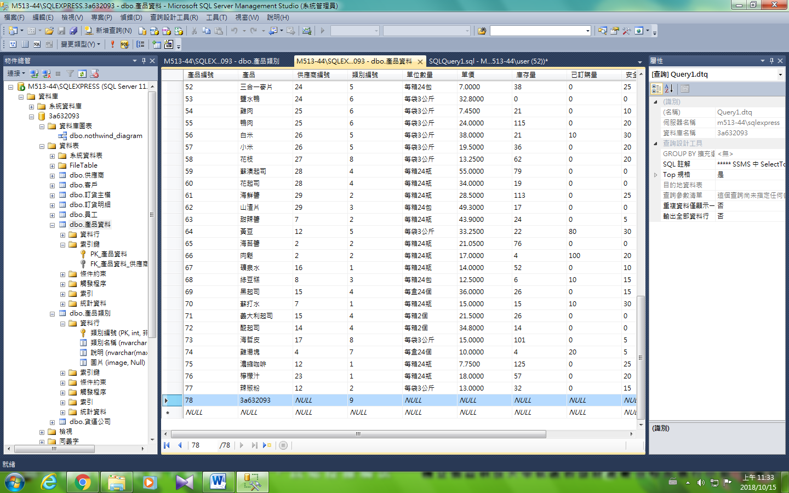

### 1.限制用法

alter table [產品資料]

add constraint fk_products_restrict

foreign key ([類別編號])

references [dbo].[產品類別]([類別編號])

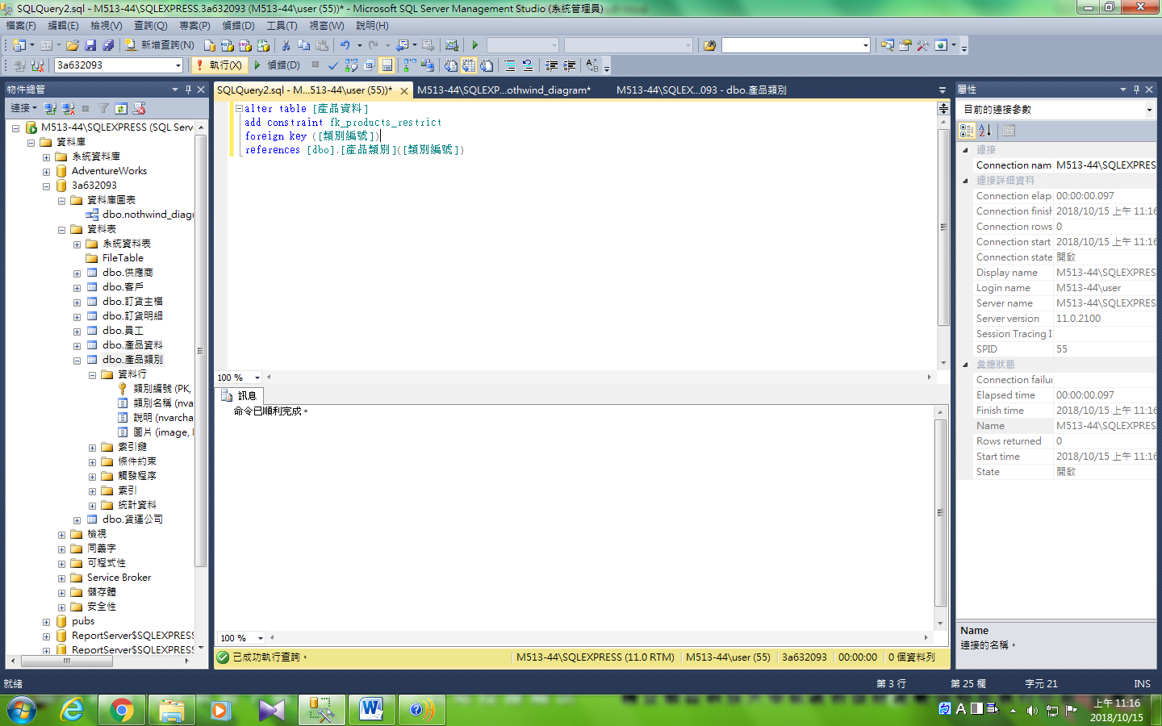

驗證

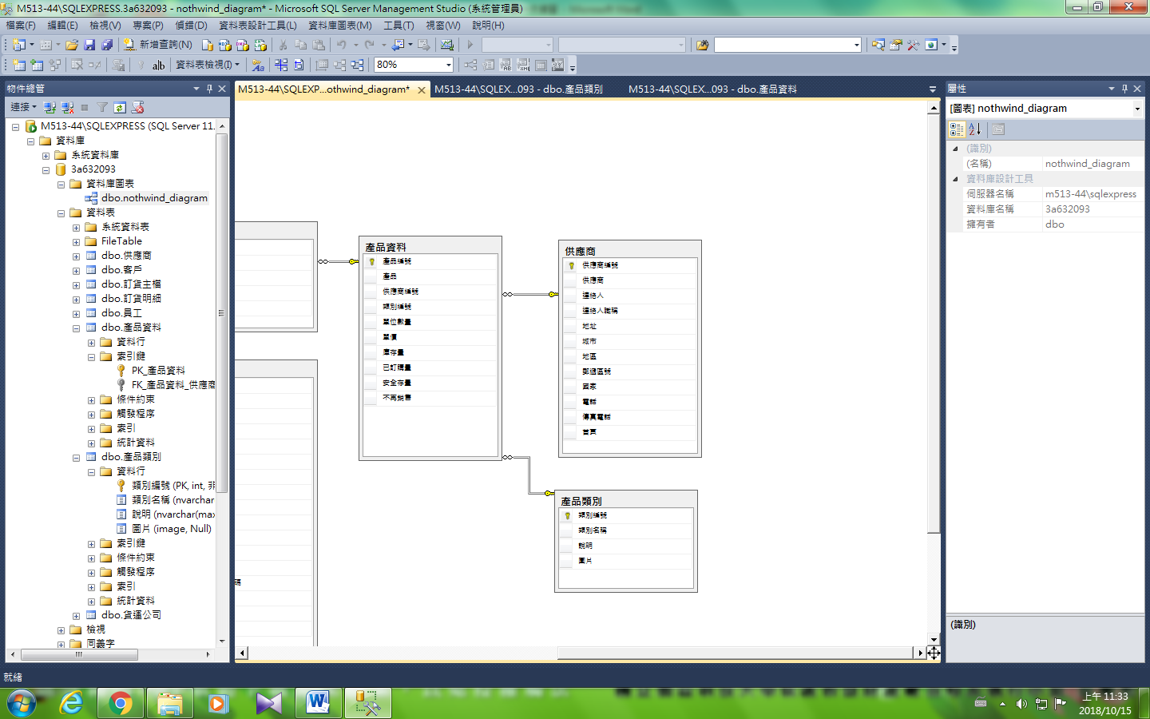

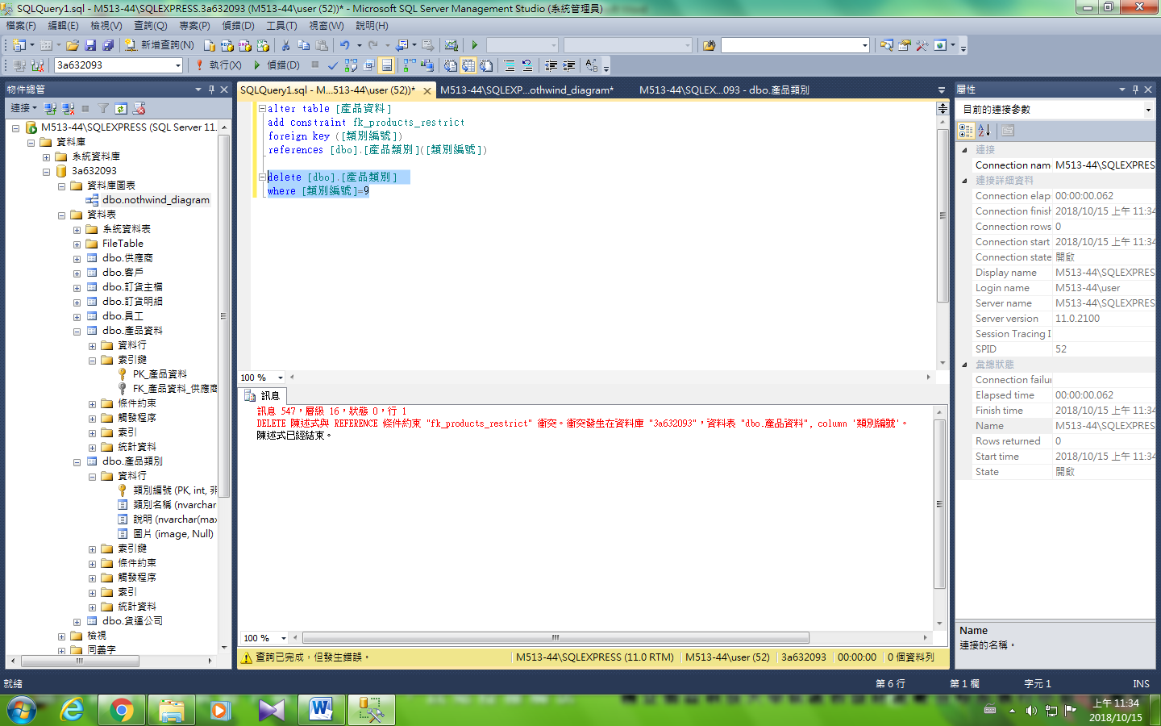

### 2.連鎖法

alter table [產品資料]

add constraint fk_產品資料_cascade

foreign key ([類別編號])

references [dbo].[產品類別]([類別編號])

on delete cascade

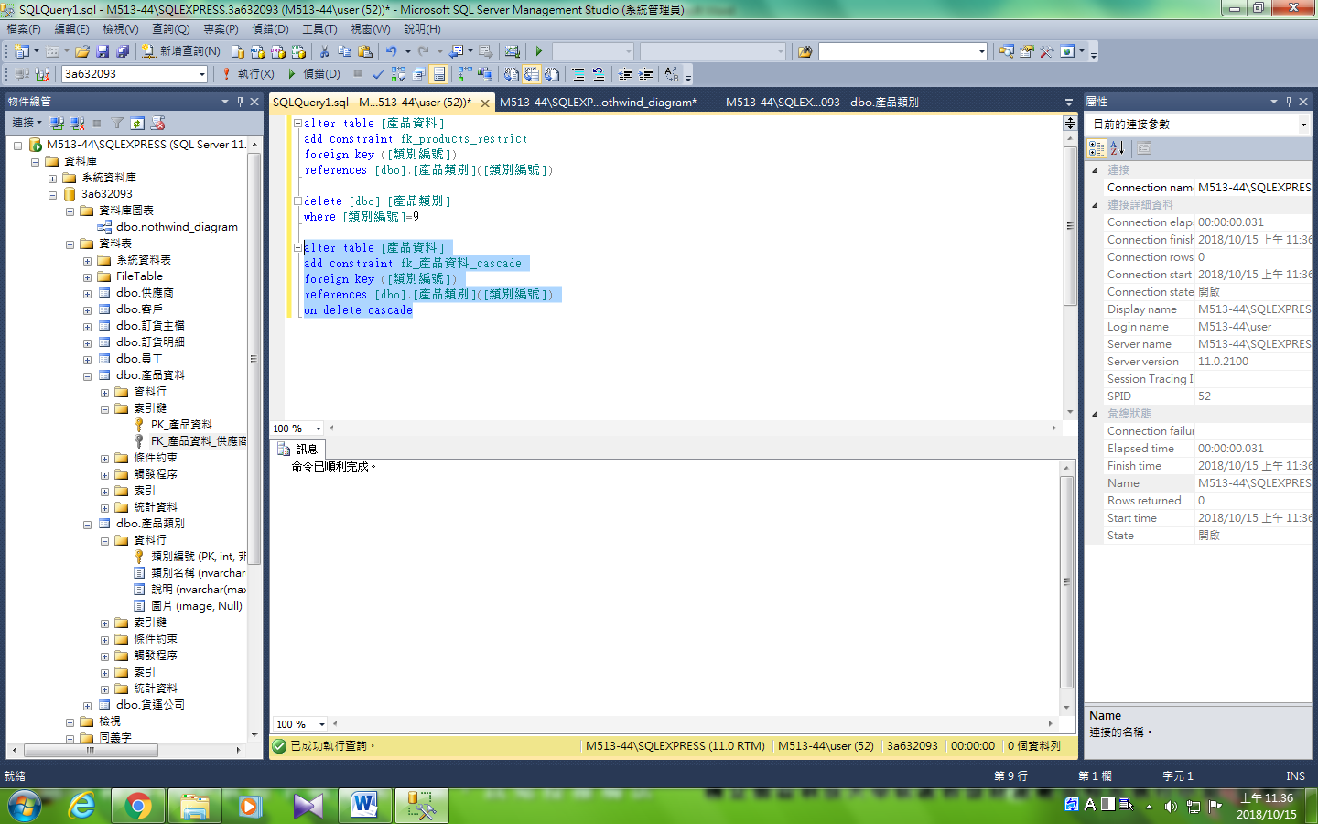

驗證

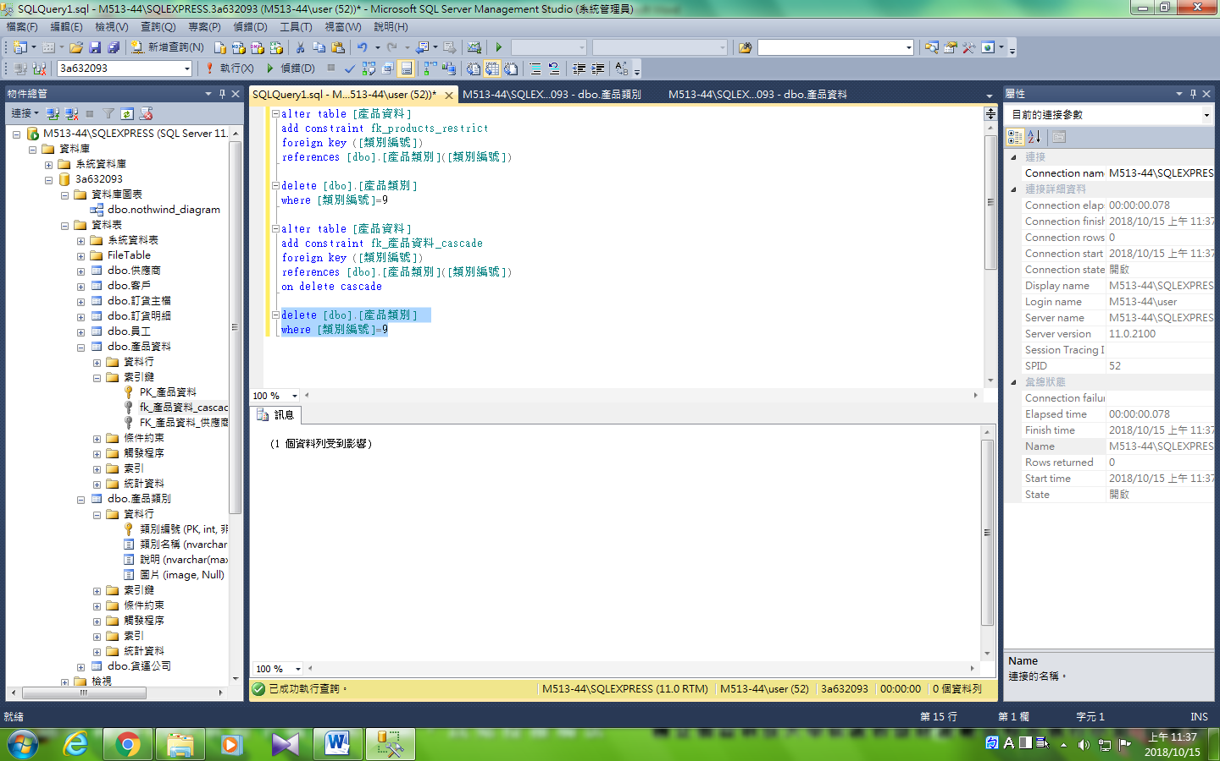

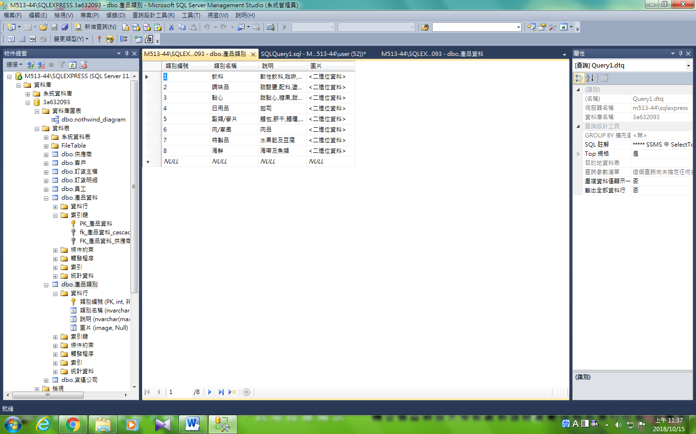

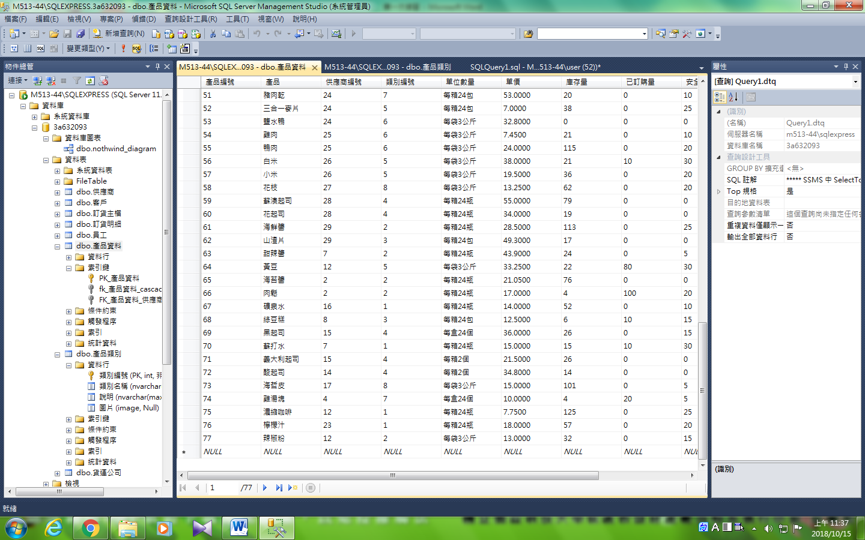

### 3.空值化法

alter table [產品資料]

add constraint fk_產品資料_null

foreign key ([類別編號])

references [dbo].[產品類別]([類別編號])

on delete set null

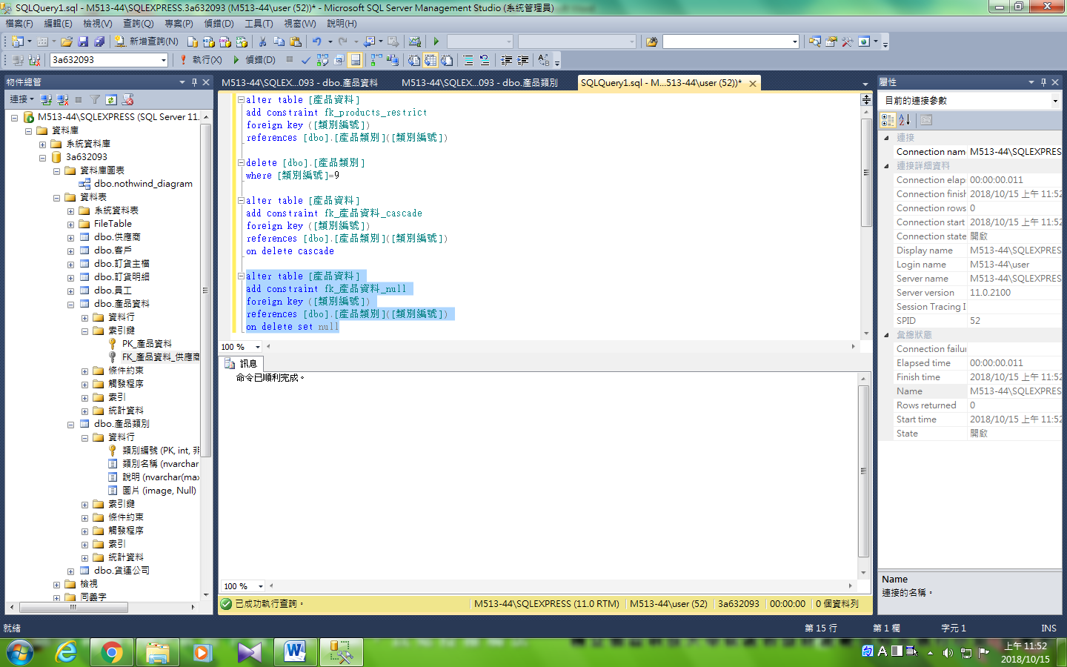

驗證

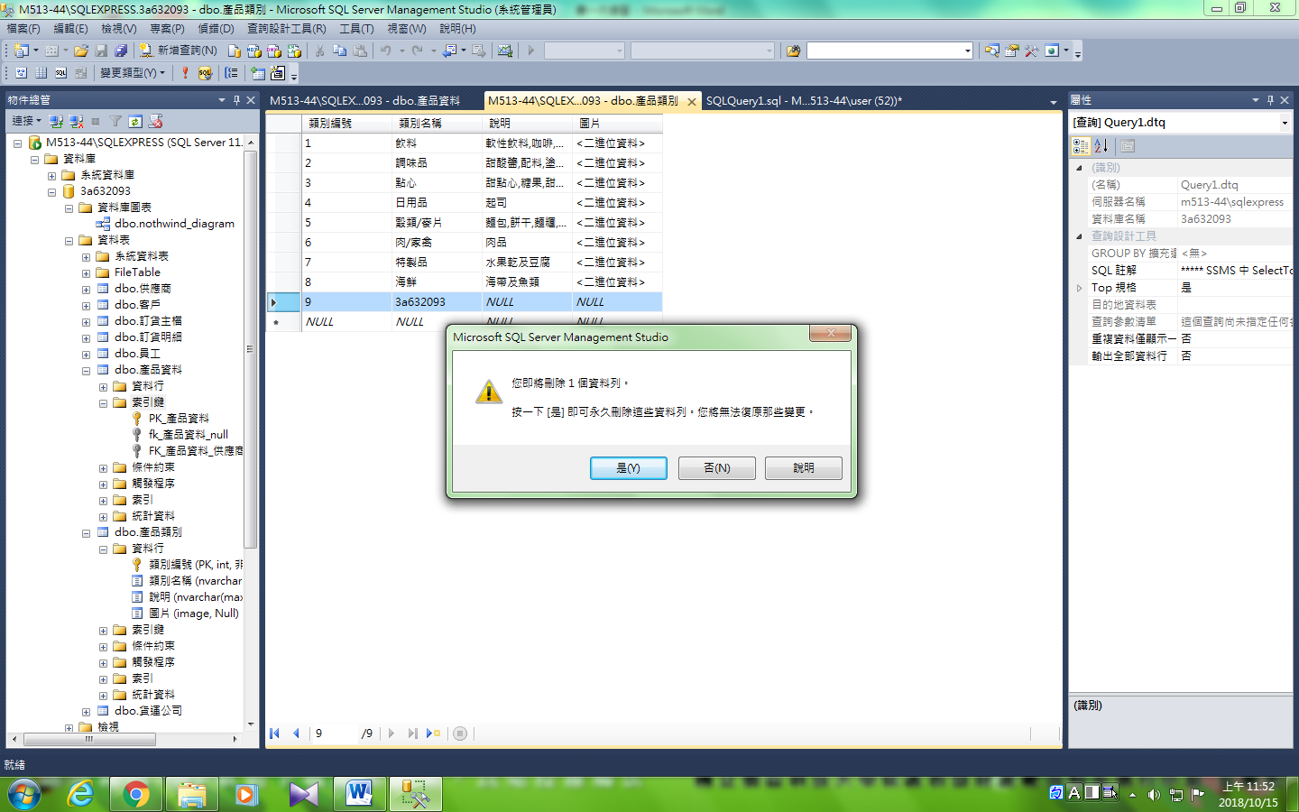

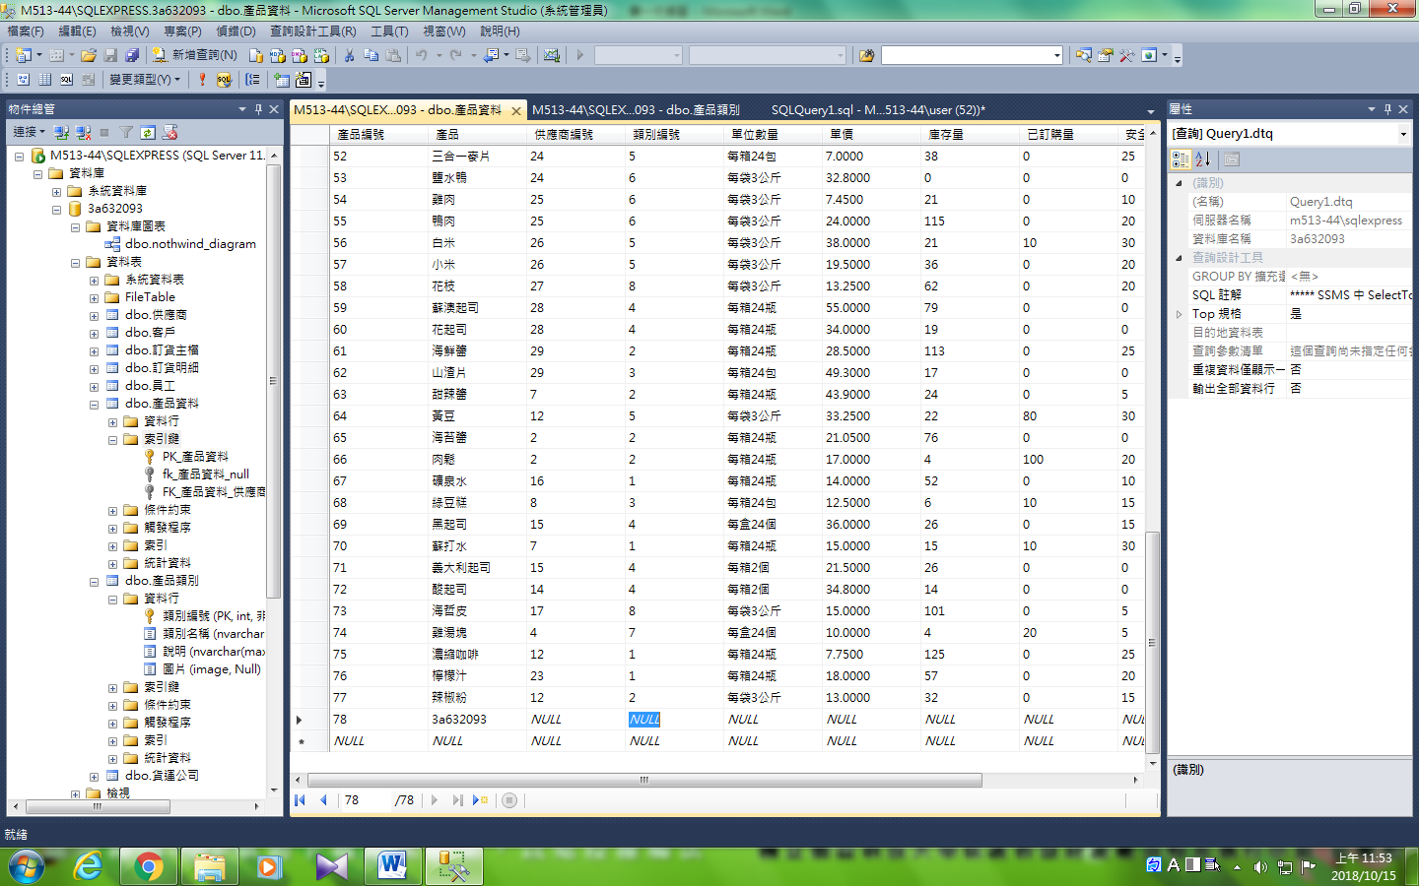

## 查詢 產品編號 53(鹽水鴨)

select *

from [dbo].[訂貨明細],[dbo].[產品資料]

where [dbo].[訂貨明細].產品編號=[dbo].[產品資料].產品編號

and [dbo].[訂貨明細].[產品編號]=53

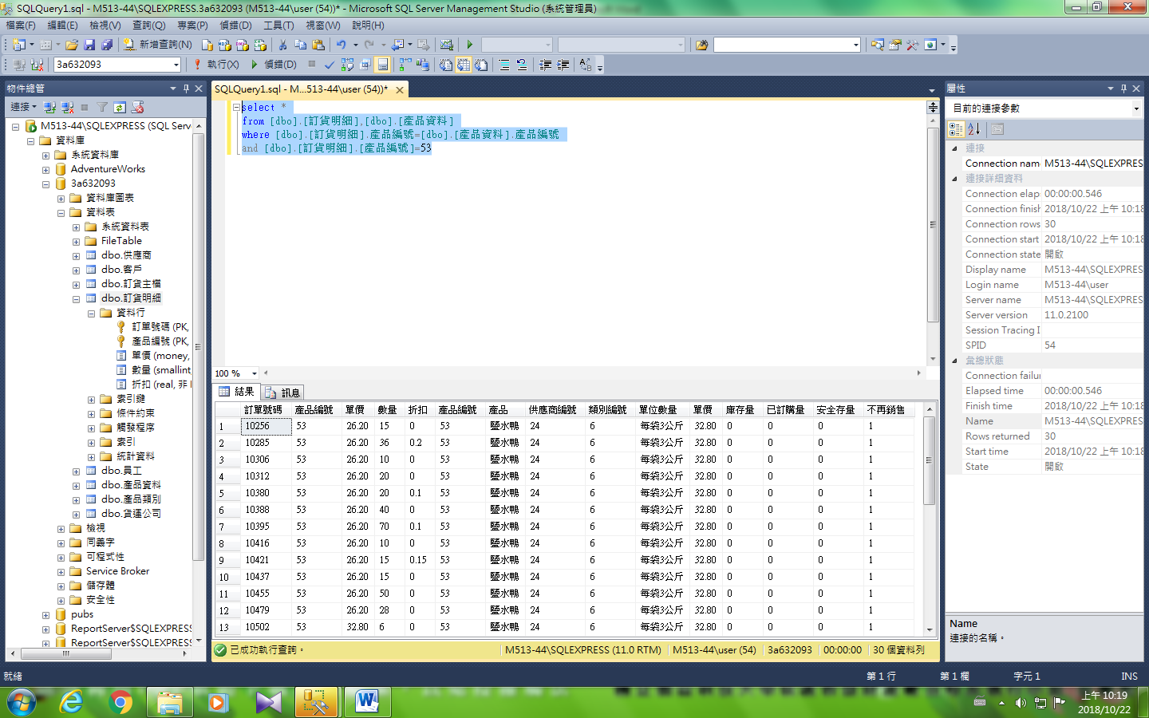

因其不再販售 而刪除鹽水鴨

delete [dbo].[產品資料]

where [產品編號]=53

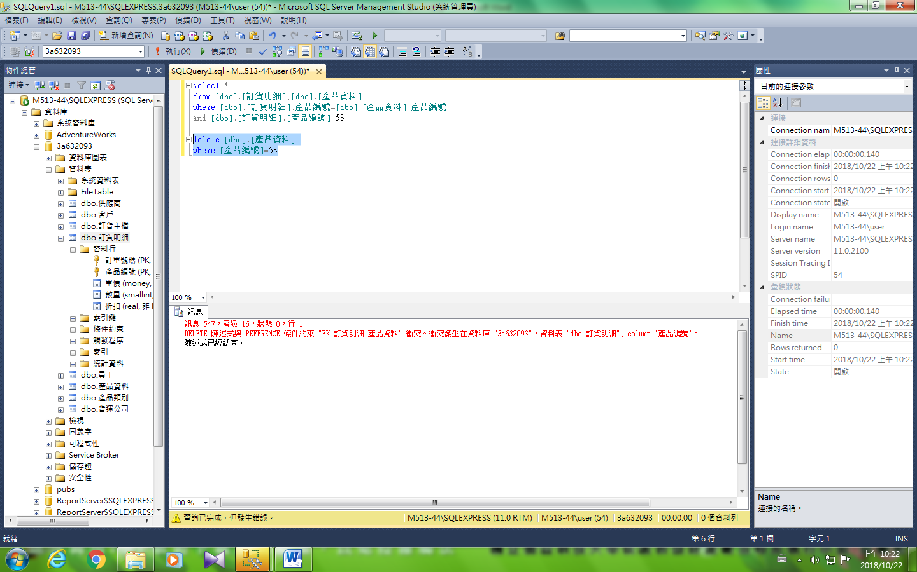

因為在訂貨明細中設定的外來鍵是限制不允許刪除

# 請寫出正規化的過程並寫出各個資料表的欄位名稱、型態與大小

|  |  |  |  |  |  |  |  |  |  |  |  |  |  |  |  |  |  |  |  |  |  |  |  |  |  |  |  |  |  |  |  |  |  |  |  |  |  |  |  |  |  |  |  |  |  |  |  |  |  |  |  |  |  |  |  |  |  |  |  |  |  |  |  |  |  |
| --- | --- | --- | --- | --- | --- | --- | --- | --- | --- | --- | --- | --- | --- | --- | --- | --- | --- | --- | --- | --- | --- | --- | --- | --- | --- | --- | --- | --- | --- | --- | --- | --- | --- | --- | --- | --- | --- | --- | --- | --- | --- | --- | --- | --- | --- | --- | --- | --- | --- | --- | --- | --- | --- | --- | --- | --- | --- | --- | --- | --- | --- | --- | --- | --- | --- |
| |  |  |  |  |  |  |  |  |  |  |  | | --- | --- | --- | --- | --- | --- | --- | --- | --- | --- | --- | | 身分證 | 姓名 | 性別 | 地址 | 車牌 | 車商 | 顏色 | 引擎 | 違規事項 | 罰金 | 違規日期 | | A22345 | 張三 | 女 | 彰化市介壽路3號 | Xyz123 | 三陽 | 白 | 1600 | 超速 | 1700 | 2005/1/1 | | B13456 | 李四 | 男 | 員林鎮中山路4號 | Uvw234 | 福特 | 紅 | 1000 | 闖紅燈 | 5600 | 2005/1/1 | | Rst345 | 裕隆 | 藍 | 2000 | 酒醉駕車 | 16000 | 2005/2/2 | | C14567 | 王五 | 男 | 鹿港鎮中正路5號 | Opq456 | 豐田 | 綠 | 3000 | 逆向行車 | 4000 | 2005/4/4 | | Lmn567 | 福特 | 黑 | 1600 | 違規左轉 | 3000 | 2005/6/6 | | Lmn567 | 福特 | 黑 | 1600 | 未帶駕照 | 7000 | 2005/6/6 | |

### 1st NF

|  |  |  |  |  |  |  |  |  |  |  |  |  |  |  |  |  |  |  |  |  |  |  |  |  |  |  |  |  |  |  |  |  |  |  |  |  |  |  |  |  |  |  |  |  |  |  |  |  |  |  |  |  |  |  |  |  |  |  |  |  |  |  |  |  |  |  |  |  |  |  |  |  |  |  |  |  |  |
| --- | --- | --- | --- | --- | --- | --- | --- | --- | --- | --- | --- | --- | --- | --- | --- | --- | --- | --- | --- | --- | --- | --- | --- | --- | --- | --- | --- | --- | --- | --- | --- | --- | --- | --- | --- | --- | --- | --- | --- | --- | --- | --- | --- | --- | --- | --- | --- | --- | --- | --- | --- | --- | --- | --- | --- | --- | --- | --- | --- | --- | --- | --- | --- | --- | --- | --- | --- | --- | --- | --- | --- | --- | --- | --- | --- | --- | --- |
| |  |  |  |  |  |  |  |  |  |  |  | | --- | --- | --- | --- | --- | --- | --- | --- | --- | --- | --- | | 身分證 | 姓名 | 性別 | 地址 | 車牌 | 車商 | 顏色 | 引擎 | 違規事項 | 罰金 | 違規日期 | | A22345 | 張三 | 女 | 彰化市介壽路3號 | Xyz123 | 三陽 | 白 | 1600 | 超速 | 1700 | 2005/1/1 | | B13456 | 李四 | 男 | 員林鎮中山路4號 | Uvw234 | 福特 | 紅 | 1000 | 闖紅燈 | 5600 | 2005/1/1 | | B13456 | 李四 | 男 | 員林鎮中山路4號 | Rst345 | 裕隆 | 藍 | 2000 | 酒醉駕車 | 16000 | 2005/2/2 | | C14567 | 王五 | 男 | 鹿港鎮中正路5號 | Opq456 | 豐田 | 綠 | 3000 | 逆向行車 | 4000 | 2005/4/4 | | C14567 | 王五 | 男 | 鹿港鎮中正路5號 | Lmn567 | 福特 | 黑 | 1600 | 違規左轉 | 3000 | 2005/6/6 | | C14567 | 王五 | 男 | 鹿港鎮中正路5號 | Lmn567 | 福特 | 黑 | 1600 | 未帶駕照 | 7000 | 2005/6/6 | |

### 2nd NF 功能相依圖

### 關聯表

駕駛人

|  |  |  |  |
| --- | --- | --- | --- |
| 身分證 | 姓名 | 性別 | 地址 |

車輛

|  |  |  |  |
| --- | --- | --- | --- |
| 車牌 | 製造商 | 顏色 | 引擎 |

違規對照表

|  |  |
| --- | --- |
| 違規事項 | 罰金 |

違規

|  |  |  |  |
| --- | --- | --- | --- |
| 身分證 | 車牌 | 違規事項 | 違規日期 |
| A22345 | Xyz123 | 超速 | 2005/1/1 |